Interfaith Peace Camp!

July 16th-20st 9am-3pm

2018 Camper Registration

Return to Ms. Perry c/o ARC, 24 Delay Street, Danbury, CT 06810
Or email: PJL@ARCFORPEACE.ORG (put Camp in email “Subject”

Or by email to dreamhomes@arcforpeace.org or by Fax to (203) 792-9452 (Att. Elke Sweeney)

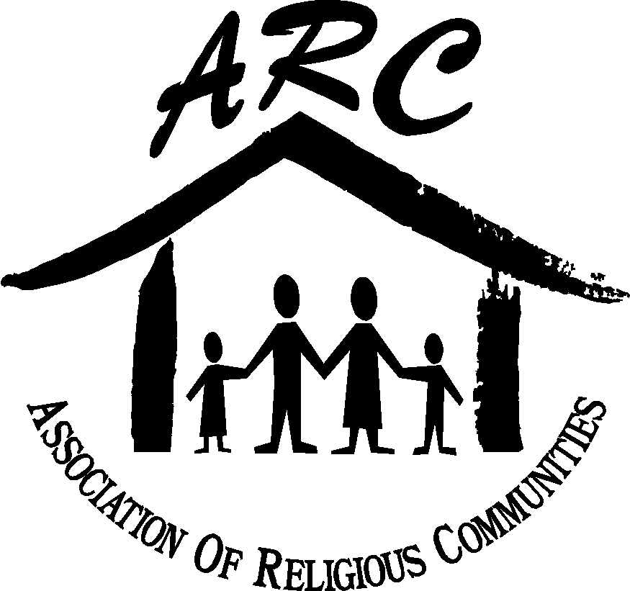

- Contact Information

Child’s name_____________________________________ Birth Date____________ Sex ____

Street_____________________________________ City______________ State____ Zip______

Child’s School: ___________________________ Child will be entering grade _______in September

1st Parent/Guardian 2nd Parent/Guardian

Name_____________________________ Name _______________________________

Home Address (if different from child) Home Address (if different from child)
__________________________________ ____________________________________

Daytime Phone______________________ Daytime Phone_______________________

Email______________________________ Email ______________________________

B) Activity Release

I, ______________________, hereby acknowledge that _______________________ is physically fit & able
(PARENT / GAURDIAN NAME) (CHILD’S NAME)

to participate in Interfaith Peace Camp, which may include, but is not limited to sports, yoga, dance movements, games, cooking, or crafts. I am aware these activities may entail risks of injury and understand that ARC, camp facilitators, speakers, counselors, and participating religious communities will not be liable for any injuries, damages, etc.

C) Authorization to Release Agreement

The following 2 people are authorized to pick up and drop off my child. I understand that my child will not be released to any other persons without my written permission. I also understand that unless there is a court order to the contrary, both parents have legal authority to pick-up their child(ren) at any time.

Name 1.____________________________________ Name 2 ________________________________

Relation to child_____________________________ Relation to child: ________________________

Daytime Phone _____________________________ Daytime Phone: _________________________

(Please include here only people who are not parents or legal guardian of the child.)

D) Transportation Agreement

Check one: _____ My child will take the bus _____ Send me directions (to drop off & pick up
my child at each site)

D) Transportation Agreement, Continued

If you checked “Send me directions” on previous page, please check one:

_____ Send driving directions to my email _____ Send driving directions by postal mail

If sending to email, please print your email address:_____________________________________

E) Medical Emergency

Child’s name _______________________________ Birth Date___________ Sex____
Emergency Contacts:

Name _____________________________________ Home Phone_____________________________

Business Phone_____________________________ Cell Phone/Pager__________________________

Physician___________________________________ Physician Phone__________________________

Dentist_____________________________________ Dentist Phone ____________________________

Health Insurance Carrier_______________________ Phone ___________ Policy #_________________

List any Allergies (food, meds, etc.) _____________________________________________________

List any Food Restrictions____________________________________________________________

List any Medication and significant medical info__________________________________________

F) Terms and Conditions
I/We ___________________________ give my child (or children) permission to attend and participate in activities associated with Interfaith Peace Camp (IPC), organized by the Association of Religious Communities (ARC) in collaboration with other entities. I further understand that I am financially responsible for any damage done by my child (or children) to any person, persons or property (including host locations). I, for myself and child (or children) named in this Application hereby WAIVE, RELEASE, AND HOLD HARMLESS the Association of Religious Communities and any entity involved in IPC (inclusive of employees, other participants, and all employees, staff, and volunteers of the ARC Board of Directors and/or other entities or entities acting on their behalf) from and against any and all claims, liability, damages, cost or expenses (including attorney’s fees) arising out of or related to our participation or use of the facility. I am aware that by signing this application, I assume all risks and waive and release all substantial rights that I may have and possess. I give permission for my child (or children) to participate in IPC. I understand that my child will be under the direct supervision of IPC staff and volunteers while in or outside of meeting spaces, which may include a swimming pool. My child agrees to abide by all established rules of conduct and knows that failure to follow said rules could result in removal from the program. I further give permission for IPC staff and volunteers to take appropriate measures including contacting emergency medical services in case of medical issues. It is understood that conscientious effort will be made to notify me before such action is taken. I hereby relieve ARC and its representatives of all responsibility and consequences that might arise as a result of this treatment and/or programming. I agree to accept any and all financial responsibility as a result of such treatment. I have read this application and have explained the Terms and Conditions to my child (or children) named in the application.

I, _______________________, give ARC and/or camp director permission to take whatever emergency
(PARENT / GAURDIAN NAME)

measures (e.g. first aid, disaster evacuation) that are judged necessary for the care and protection of my child while under the supervision of ARC's Interfaith Peace Camp. In the case of a medical emergency, I understand that my child may be transported to an appropriate medical facility either by the Director of ARC's Interfaith Peace Camp or by a local emergency unit if it is deemed necessary. Any expenses incurred will be my responsibility. I understand that in some medical situations, the local emergency resource may need to be contacted before either parent, the child's physician, and/or the other emergency contacts listed on this form.
F) Religious Affiliation

If you are affiliated with a faith community, please write the name of your religious affiliation or the

name of your congregation: ________________________________________________________

___________________________________________________ __________________
(Signature of Parent or Guardian) (Date)

